Satake FMS2000 Optical Sorter Guide

Nathalie Rusu Sirbu

1. The Parts of the machine

Opening 2

Feeder

Opening 1

Interface

Plastic screen over optical sorting

Accept Chute

Reject Chute

Power Switch

2. Using the machine

* A red and yellow switch on a white wall

  Description automatically generatedA screen on a machine

  Description automatically generatedTo begin, the machine needs to be turned on by turning the power switch counterclockwise. It will then need to warm up for 30 minutes.
* It is important that the air is also turned on so that the machine gets air pressure to function. If it is not turned on, there will be a warning.
* A screen shot of a computer

  Description automatically generatedA screen with text on it

  Description automatically generatedA screen on a device

  Description automatically generatedTo sort beans, click on the top left side of the interface, select the bean type you want, and press select. Then you can go back to the main menu and press Start.
* 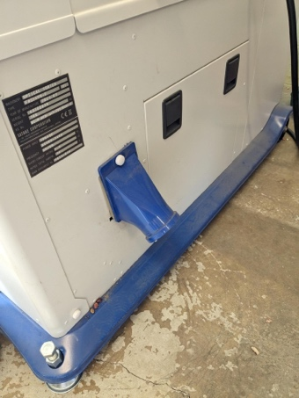A bucket with a metal spout coming out of it

  Description automatically generatedBefore you start sorting the beans, make sure there is a bucket under the reject chute, and a tin or another bucket under the accept chute.
* A metal square with a hole in the middle

  Description automatically generatedPour the beans down the feeder using a step ladder, then step down and make sure that the beans from the accept chute don’t make the chosen container overflow.
* Make sure to empty the bucket under the reject chute each time (in case there is a mistake, you can still keep the same genotype).
* Repeat!

3. Adding a new market class

* To add a new type of bean, you first need to ensure that you press “stop”. Otherwise, there will be an error later on.
* A blue device with a screen

  Description automatically generated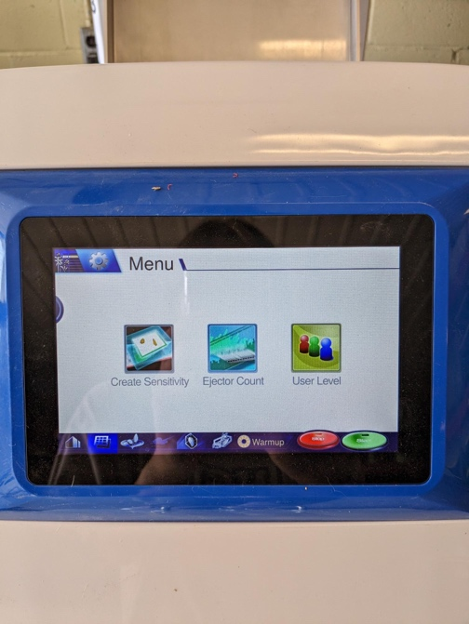A blue device with a screen

  Description automatically generatedFrom there, you have to change the user level by going on the bottom bar. Switch from “user” to “engineer” by inputting the password: 452124
* A blue electronic device with a screen

  Description automatically generatedGo back to the main menu, press the top left of the interface, then change to “Master of Reflection”. Press on “add new”, then change the name to the bean you are adding.

1. Accepts

* A blue and white device with a screen

  Description automatically generatedA blue and white device with a screen

  Description automatically generatedThen go to the bottom bar, click “create sensitivity”, click the button that looks like a big grid, then the button on the right that looks like a deck of cards.
* A machine with a white sheet

  Description automatically generatedA metal box with a lid open

  Description automatically generated with medium confidenceTo start adding beans, you need to remove the plastic covering by opening both “opening 1” and “opening 2”. There are three hooks that keep the plastic there. Unhook the plastic sheet and slide it out (carefully) either through the top or the bottom. Then, close both openings.
* Once the “deck of cards” has been chosen, it will say “waiting for trigger”. You can then pass one bean through by dropping it starting at the top of the optical sorting tube (underneath opening 2). Make sure to select beans that are all uniform in colour (i.e. no splits or broken beans).
* To properly identify the accepts, add 20 beans in this section. Make sure to wait until the interface says “waiting for trigger”. If you accidentally pass something else or it takes a picture automatically, long hold on the picture and you can delete it and then continue.
* A close up of a screen

  Description automatically generatedOnce you have added at least 20 images, press “save” and then “create profile”. Now you can move on to the rejects.

1. Rejects

* Adding the rejects is the same process as the accepts. Press “reject 1”, and you can change the name to whatever reject it is. Most commonly it is splits, other beans commonly found with the bean you’re trying to sort, or even big clumps of dirt.
* Follow the same process as above but add only 5 rejects. Make sure that all 5 are the same type of reject and that you can clearly see the difference in colour between the front and the back (i.e., for a split, the front side would be darker, while the back is white).
* 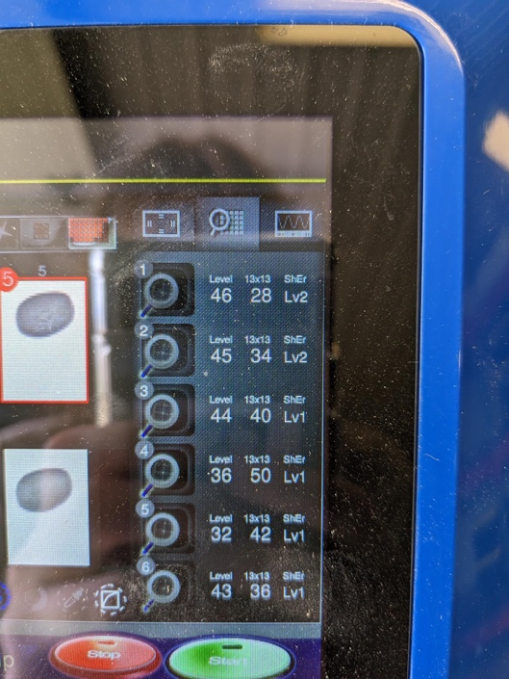A screen with red and white images

  Description automatically generated with medium confidenceTo see what is being targeted with the rejects, make sure you save pictures and upload profile (for each individual one) and then you can press the magnifying class. This will highlight in red what parts are being targeted. To make sure what you want to be accepted won’t also be rejected, you can click on “accepts” and see if they also appear red. If they do, you can go into each individual reject’s magnifying glass and decrease the sensitivity (or vice versa if the rejects aren’t being targeted)
* A screen with a number on it

  Description automatically generatedTo fine tune what is being targeted, you can use the settings on the side. The first one (sensitivity) will become redder as you increase the numbers. However, like above, make sure the accepts aren’t being targeted as well. You can adjust all the values for every different type of reject, and once that’s done, press save profile.

1. Rejects based on size and shape instead of colour

* A screen with buttons on it

  Description automatically generatedIf the colour of the reject and accept are the same, you can differentiate based on shape – the process is the same as above.

1. Finishing a new creation

* Once you make sure all the pictures are saved and the profiles are created, you can go to the menu where you see all the types of beans. Make sure you press save on the profile itself!
* Before you restart using the machine, make sure you put the plastic screen covering back on. Reopen openings 1 and 2 and slide the screen either from the top or the bottom, making sure it gets hooked. Close both openings. Then you can select this bean type and use the machine like outlined in step 2.

1. Cleaning

* A close-up of a machine

  Description automatically generatedTo clean the machine and get rid of any debris, you can use air pressure gently on the inside of the screen and around the machine.